**DAILY ONLINE ACTIVITIES SUMMARY**

|  |  |  |  |  |  |
| --- | --- | --- | --- | --- | --- |
| **Date:** | **18 June 2020** | | **Name:** | **KHATHEEJA SAFREENA.** | |
| **Sem & Sec** | **4th sem, 2nd year** | | **USN:** | **4AL18CS037.** | |
| **Online Test Summary** | | | | | |
| **Subject** | **----------------** | | | | |
| **Max. Marks** | **---** | **Score** | | **-------** | |
| **Certification Course Summary** | | | | | |
| **Course** | **INTRODUCTION TO INFORMATION SECURITY.** | | | | |
| **Certificate Provider** | **GreatLearning** | **Duration** | | | **6 hours** |
| **Coding Challenges** | | | | | |
| **Problem Statement:** 1.Find the smallest positive integer value that cannot be represented as sum of any subset of a given array sorted in ascending order. | | | | | |
| **Status: Executed** | | | | | |
| **Uploaded the report in Github** | | **Yes** | | | |
| **If yes Repository name** | | http://shafreenasharief / lockdown-coding  http://shafreenasharief / locked-down--certification-course  **[http://shafreenasharief / Daily\_Report](http://shafreenasharief / Daily_Report" \o "http://shafreenasharief / Daily_Report)** | | | |
| **Uploaded the report in slack** | | **Yes** | | | |

Certification Course Details: (Attach the snapshot and briefly write the report for the same)

Coding Challenges Details: (Attach the snapshot and briefly write the report for the same)

**CERTIFICATION COURSE SUMMARY:**

Today I started new course **INTRODUCTION TO INFORMATION SECURITY** through **GREAT LEARNING** the course is secluded for 6hrs. After the completion of course, certificate will be provided. I completed all the module .I attempted quiz ,which gave me a clear veiw about the topics that were thought and discussed.It consists of 7 modules which also include assessments.

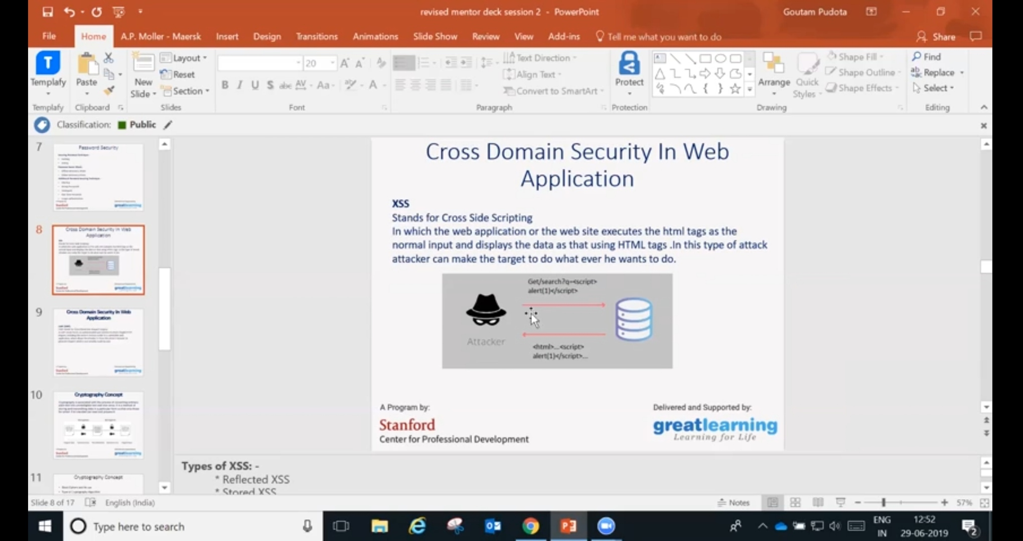

**CODING CHALLENGES**

Today I solved coding challenge,

**Find the smallest positive integer value that cannot be represented as sum of any subset of a given array sorted in ascending order.**

Given a sorted array (sorted in non-decreasing order) of positive numbers, find the smallest positive integer value that cannot be represented as sum of elements of any subset of given set  
**Examples**:

Input: arr[] = {1, 3, 6, 10, 11, 15};  
Output: 2  
There are no one or more elements to be added up to get sum = 2

**Input**: arr[] = {1, 1, 1, 1};  
**Output**: 5  
1 = 1, 1+1 = 2, 1+ 1 + 1 = 3, 1 + 1 + 1 + 1 = 4,  
There is no elements in the array to get sum 5

**Input**: arr[] = {1, 1, 3, 4};  
**Output**: 10  
1 = 1, 1 + 1 = 2, 3 = 3, 1 + 3 = 4, 1 + 4 = 5, 1 + 1 +4 = 6, 3 + 4 = 7........  
To get sum 10, there is no elements in the array.

**Input:** arr [] = {1, 2, 5, 10, 20, 40}  
**Output**: 4  
There are no elements to get sum = 4.

**Input**: arr[] = {1, 2, 3, 4, 5, 6}  
**Output**: 22

I tried the program in Python.

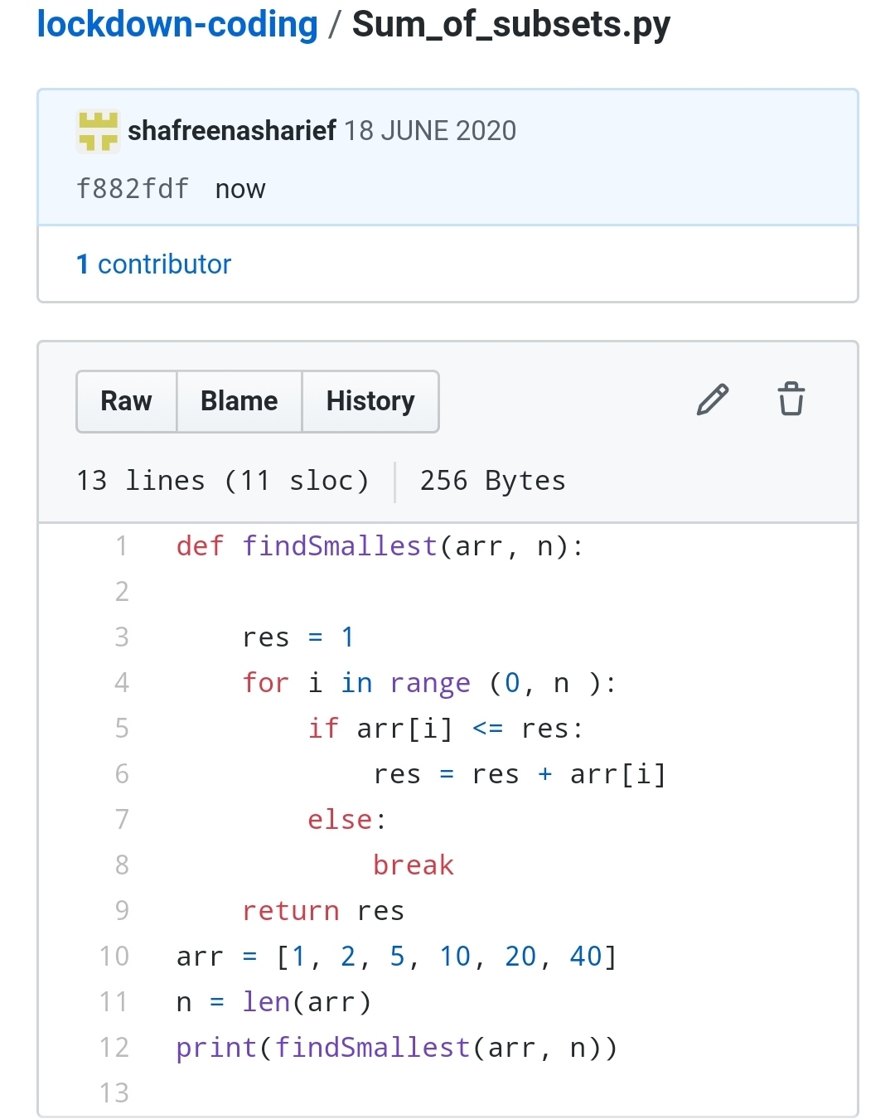

**SOLUTION : I have uploaded the solution of the above 3 coding problems in my GitHub repository.**

**[http://shafreenasharief / lockdown-coding](http://shafreenasharief / lockdown-coding" \o "http://shafreenasharief / lockdown-coding)**

**[http://shafreenasharief / locked-down--certification-course](http://shafreenasharief / locked-down--certification-course" \o "http://shafreenasharief / locked-down--certification-course)**

**[http://shafreenasharief / Daily\_Report](http://shafreenasharief / Daily_Report" \o "http://shafreenasharief / Daily_Report)**